Edelweiss Datacap Solution

Datacap Desktop Configuration Guide

Table of Contents

1 Document Control 1

1.1 Version History 1

2 Introduction 1

2.1 Purpose 1

3. Datacap Desktop Configuration 1

# 1 Document Control

## 1.1 Version History

|  |  |  |  |
| --- | --- | --- | --- |
| Version | Date | Change Description (include list of reviewers) | Author |
| V1.0 | 14-09-2018 | Released version | MITS |

# 2 Introduction

## 2.1 Purpose

The purpose of this document is to provide instructions for Edelweiss to understand on Deployment of Datacap Application

# 3. Datacap Desktop Configuration

1. Copy the “Edelweiss_N” folder from attachment to below path in the UAT System.

**Eg:** C:\Datacap\

**Note**: C:\ (or) D:\ depends upon where datacap is installed.

1. Open datacap.xml which is available in below path

**C:\Datacap\datacap.xml**

1. Add the below mentioned in datacap.xml file and Save the file**.**

**<app name="Edelweiss_N" ref="C:\Datacap\Edelweiss_N"/>**

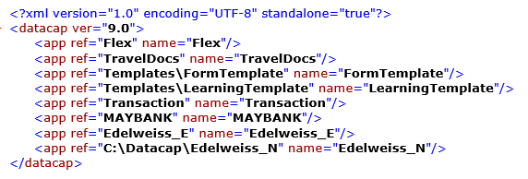

1. Open Datacap **Application Manager** as Run as **Administrator.**

4.1 Open below **Service** Tab and Update below value.

**Note:** Make sure below Path is accessible from **windows + run**

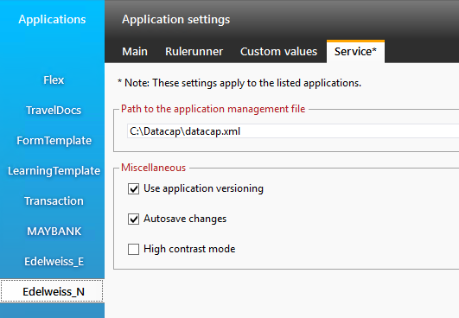

* 1. Open below **Custom Values** Tab and Update below values in General Settings
* FilenetUrl
* ObjectStore
* FilenetUserName
* MovetoDirectory
* uploadimage

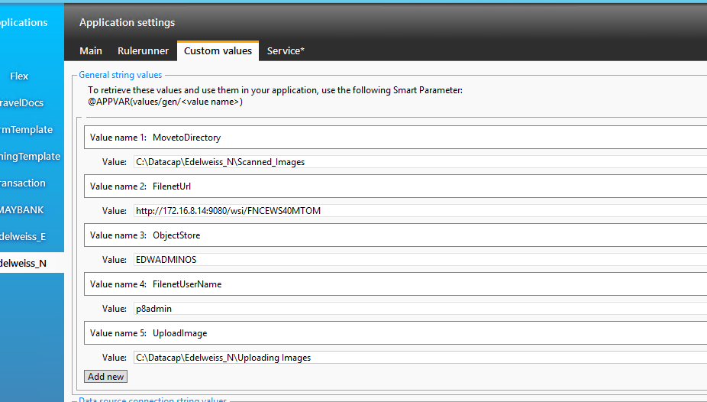

* 1. Open below Custom Values Tab and Update below values in General Settings
* FilenetPassword

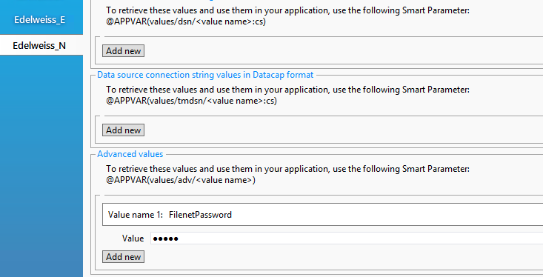

* 1. Open below Main Tab and Update below values in WorkFlows
* Vscan Source Folder

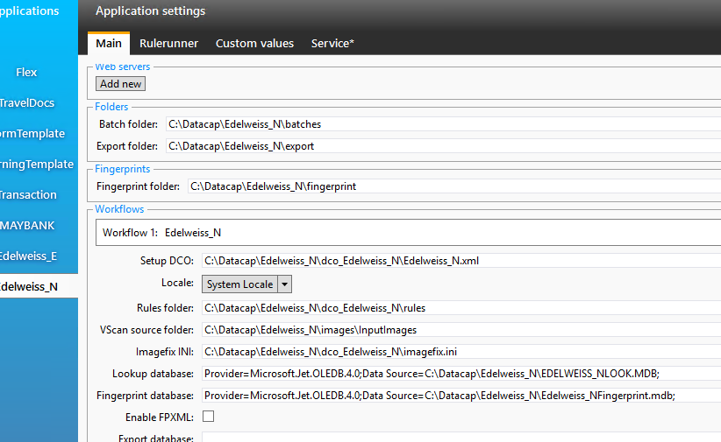

Click **Save Changes** and close application manager.

**Note** : Change the all paths available in Application Manager if datacap is not installed in C drive

1. Execute the Attached DB scripts in your DB2 schemas
2. Copy the “edel_config.xml” to c:\ drive

**Note** :Change the “CONNECTION_STRING” in the edel_config.xml file according to your database.

1. Copy the “DotEditPanels.dll” to below path

Copy all the below files to **\\InstalledDir\Datacap\DcDesktop\**

Ex: **C:\Datacap\DcDesktop\ (Datacap installed in C Drive)**

Note: Make sure all required ports should be opened between the user machine and the DB2 server.

1. Open Rule Runner Manager to Configure Threads

* Open Rulerunner login tab
* Enter User Id, Password, Station Id and click on connect.

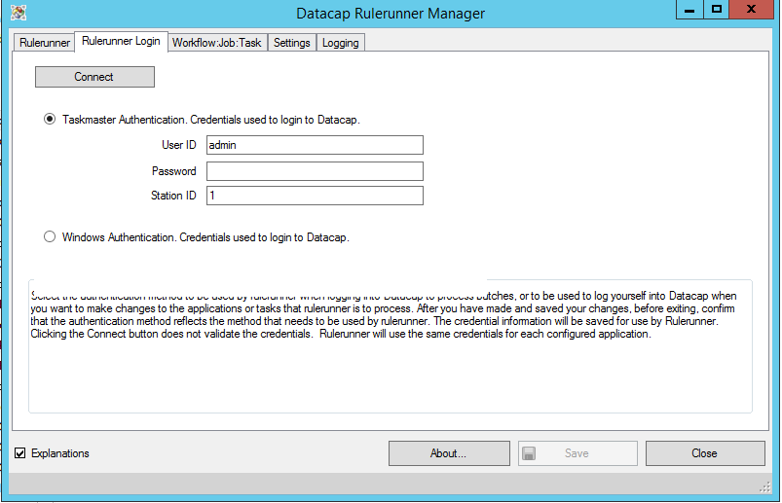

* Go to WorkFlow:Job:Task Tab
* Right Click on Right side Tab and Add thread
* Select Application and Vscan from left side panel.
* Drag and Drop on Thread0.
* Repeat the above steps and Create threads for PageId,Profiler,Export.

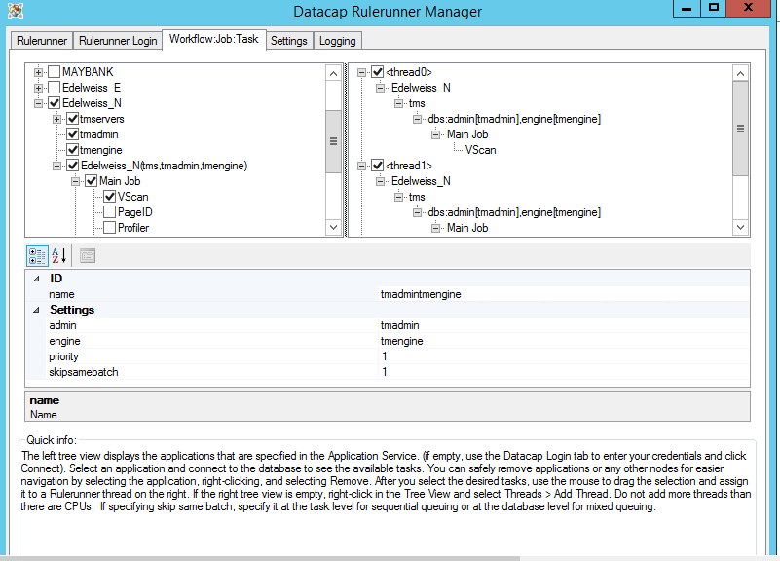

Click on Save and Close RuleRunner Manager .

1. Please check all datacap Services are running or not.If not please start the services.
2. Place the Images in the Scan Source Folder.

Open **Datacap Desktop** from **All Programs -> IBM Datacap Clients -> Datacap Desktop**

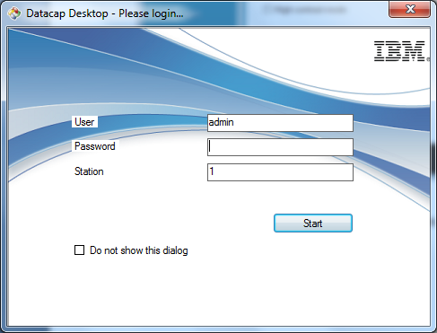

Provide Login **User**, **Password** and **Station** assigned and click **Start**

Select **Application** from **list** shown below and start Checking the documents

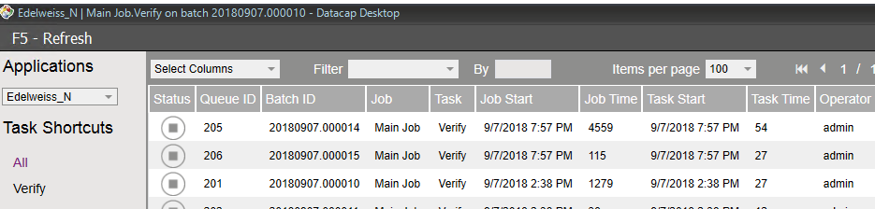.

*****************End of Document*****************